BASIC BEARDED DRAGON

CARE TIPS AND INFORMATION
By: Johnothan E. Wallace 8-28-13 – Updated 8-17-2020

What is a bearded dragon?
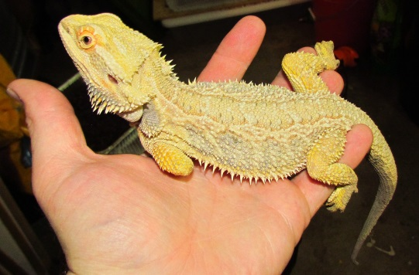
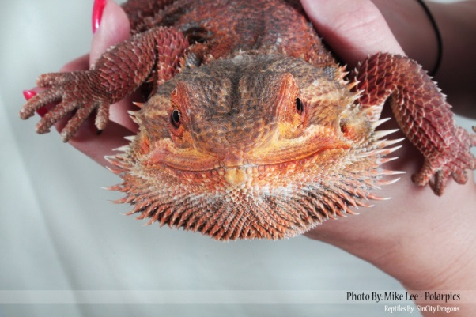
The Bearded Dragon is an agama that is only found in Australia and because of the strict exportation laws concerning the flora and fauna of Australia all bearded dragons outside of Australia today are captive bred. They have come from captive bred parents, grandparents, most likely great grandparents and much further down the ancestral line than that even. They are very rewarding to keep and study as they are highly interactive with their cage-mates, owners, and other animals that share their residence. When their basic needs are met they are very hearty and thrive in captivity. They are, in most cases, very docile and are commonly referred to as the #1 “beginner lizard” due to their temperament as well as their hardiness in captivity. Bearded dragons also come in a wide variety of colors and patterns produced through selective breeding, these are referred to as “morphs”. Some of the more commonly found bearded dragon morphs are hypo’s, leather backs, silks, translucent, and dragons line bred for color such as deep red and citrus tones. Many of these morphs are combined through years of breeding to achieve some truly impressive looking lizards but what draws most people in to keeping bearded dragons is still their personality, the looks are still just the icing on the scaly cake.

The Basics
Size: Adult size can range from 15” to 26” depending on blood lines.
Longevity: 8 to 12 years is the common life span but longer is not unheard of.
Diet: Bearded dragons are omnivores consuming mostly insects and dark leafy
greens in captivity. This will be discussed in more detail further down.
Type of Habitat: Bearded dragons hail from an arid environment. They like it hot and dry though the occasional misting is usually welcome, even the desert gets rain sometimes. A low constant humidity is fine as long as the enclosure has as decent amount of air flow so that the air is not stagnant and breeding bacteria which is what causes most upper respiratory infections in dragons associated with excessive humidity.

Enclosures

Cage Size

Starting Off Babies
A 20 gallon long tank is a good size rearing tank, it will last one dragon up until 9 inches or 2-3 dragons up to about 7 inches. After this they will need to be moved to a larger permanent tank. With single or pairs of bearded dragons it is better to start with a medium-sized enclosure and graduate to a larger one later. The reason for this is that a large open space has a tendency to make young dragons very insecure and therefore react defensively as well as it causes undue stress. Keep in mind, their natural instinct is to stick close to somewhere to hide and dart for cover when threatened. If an enclosure is too large (in the beginning) they may feel exposed and act accordingly.

Sub-Adults and Beyond
A 75 gallon breeder/reptile tank is a minimum for a single adult or sub-adult dragon. For 2 or more dragons a good guideline is at least 4 square feet of ground space per dragon, at least 20 inches of vertical space, and plenty of line-of-site-blockers within the cage. These are items that allow a visual barrier between cagemates when they aren’t getting along. Multiple basking spots are best as well so that they are not fighting over heat sources. When cohabitating dragons bigger is better and try not to go with the minimum, and always have a second cage on hand in the event that they need to be separated.

Heating and Lighting
Basking spot surface temperature should be 100-110 for babies under 8 inches and 115-125 degrees for adults. I find the best type of bulbs for achieving these temperatures are the incandescent halogen flood lights you can purchase at any hardware store. However, these lights are becoming more difficult to find so I will recommend the Arcadia brand flood style heat lamps. The best way to check the surface temperature of your basking spots is to pick up an infrared thermometer. Ambient temperatures in the cage during the day should range from the low 80’s on the cool side of the cage to the high 90’s up to 100 degrees on the warm side where the basking areas are. Ideally the basking area should be set up with levels so they can choose the spot that fits their needs at any particular moment. Remember they are reptiles and need to regulate their body temperature by moving around to areas of different temperatures. Terrarium thermometers, while no good for your surface temperatures, are very handy in keeping track of ambient temperatures. The thermometer on the warmer side of the tank should be placed at least 12 inches away from the heat source just above ground level and should read at around 90 degrees give or take 5 at mid-day. Bearded dragons also need a UVB lighting. For more information on this I highly recommend visiting the Arcadia lighting guide at their website at https://www.arcadiareptile.com/lighting/guide/ This light mimics the sunlight and enables them to process and use the calcium they digest in order to avoid problems with bone and egg development. The 2 bulbs I recommend for UVB are first, the Arcadia 14% HO bulb, and second, the Reptisun 10.0 T5 high output bulb. These bulbs need to be replaced annually as the level of UVB produced does decline over time even if they still light up. Mark on the side of your cage when the light is due to be changed just like the oil shop does on you car’s windshield. Also make sure to purchase the appropriate fixture for these lamps as they do not function in just any fixture. I have also noted over the years that bearded dragons are much more active and healthy in well-lit cages so a couple of extras CFL or LED lights to brighten up a large cage may get you a much more rewarding pet.
The pro exotics temp gun
Arcadia: https://www.reptilebasics.com/arcadia-14-uvb/
Reptisun: https://www.chewy.com/zoo-med-reptisun-100-uvb-t5-ho/dp/257675

Substrates

For the Babies
For hatchlings up to 8 inches I recommend the self-adhesive cork shelf liner that can be bought at most hardware stores, just cut it to fit your tank and you can wipe it clean with damp rag once a week. If at some point the cork is just too dirty for your liking you can peel it off and replace it. This is a good thing to use because crickets can’t hide under it, your dragons can’t accidentally eat it in their haste to grab a cricket, and it gives good traction for movement. Paper towels, newspaper, butcher paper, and the brown craft paper are also suitable for young dragons as is ceramic tile cut to fit your tank but of all the things I’ve tried I still like the cork the best.

For Sub-Adult and Beyond
For dragons 9 inches or larger you can use the same thing but it has to cleaned more often. I recommend my favorite mix, the terra sahara blend at https://www.thebiodude.com/collections/single-bioactive-substrates/products/terra-sahara-36-qt-bag. The substrate should be spot cleaned daily and replaced about once every 6 months to avoid odor build up unless you set it up as a bioactive substrate. I do recommend covering your face with a good painter’s mask when dumping the substrate so you do not inhale the dust particles, it’s not any fun. Also, add some branches and rocks for climbing, these will aid in filing the sharp nails down as well as provide exercise for your dragon. Make sure any heavy cage décor is anchored securely so that your dragon/s cannot dig underneath them and get squished. Make sure the bottom piece of any pile of rocks is pressed firmly to the bottom of the cage so it has nowhere to fall to.

Food and Water

Water
With dragons under 8 inches, a shallow but stable water dish should be full of fresh water all the time. They will typically defecate in the water so keep an eye on it and replace it when needed. DO NOT soak dragons less than 8 inches unsupervised, many people do but you run the risk of them drowning and they will soak themselves in their water dish. For any dragons over 9 inches that are well-established and feeding regularly on greens I don’t personally keep a water dish. This is because they generally get all the water they need through their diet and occasionally misting the dragon directly so that they can drink fresh flowing water through capillary action.

Food
The types of food you can give your dragons and when will be on the following page, I just wanted to make a special note here that for small dragons you should chop up the greens not only to aid them in eating but also to make sure they get a variety instead of getting their fill on one leaf. Also with feeder insects the feeders should be no larger than the space between the eyes of the dragon until they reach around 8 inches at which point they should be able to eat large adult crickets without issue.

FOODS TO AVOID INCLUDE
Spinach | Broccoli | Cauliflower
Iceberg Lettuce | Avocado | Meat other than insects
Apples  Romaine lettuce | Citrus Fruit (including tomatoes) | In general avoid wild insects as they may be toxic to your dragon and may be exposed to pesticides. If you are familiar with the insect species and know for sure they are not toxic and have not been exposed to pesticides then by all means go ahead.

Suitable Foods for Your Dragons

Hatchlings up to 10 inches
- Appropriately sized crickets and roaches are a good insect to use as a staple in the diet but you can also start fresh hatchlings on flightless fruit flies and black soldier fly larvae are a great addition to any aged dragon.
- Small superworms and wax worms are treats only and should be offered one at a time to ensure they are chewed and should be no more than 10% of the weekly diet.
- GREENS/VEGGIES should be offered every day, just put them in the cage each morning replacing them the next morning. I recommend leaving them overnight because if there are any uneaten crickets or roaches in the cage they’ll be more inclined to chew on that than the sleeping lizard, and they’ll be less inclined to look for an escape from the enclosure.
- Country Greens Mix finely chopped, found at many grocery stores, contains mustard greens, collard greens, turnip greens, and or dandelion greens all of which make good staples for their diet. You can also mix in baby spring greens for variety.
- Finely chopped or grated yellow squash, zucchini, or butternut squash added to the top of a salad will often entice picky eaters as they are attracted to both the color and the smell.
- Finely chopped red chard can be mixed in with any of the above to entice picky eaters to eat their greens as they are attracted to bright colors.

Dragons 10 inches or bigger
- Crickets or Roaches are a good staple insect but remember variety is best, don’t be afraid to mix it up a little, dried and canned insects now available on the internet give you a chance to offer a wide variety of insects to your dragons. Don’t be afraid to experiment a little and see what they like. Many of mine love the dried June bugs, mole crickets, and termites.
- All the same greens you gave them as babies but guess what, you’re done with the fine chopping. Coarsely chopped just to aid in mixing is fine; They have teeth let them do the work.

Additional food sources and notes for dragons of all ages
Dragons of all ages should be offered as much variety as you are able to provide in their diet. Remember to do your research and be conscious of the nutritional content of the feeders you’re using. The nutritional values of most available feeders can be found online. You want to limit fattier insects and feeders. Be warry of commercial diets in the form of dry pellets as they often consist of undesirable ingredients like corn and wheat as fillers. Small amounts of these things are acceptable, but not generally recommended. I do however fully endorse the use of Repashy brand diets such as Grub Pie and Beardy Buffet both of which I personally use in the diet of my dragons.
Staple insects such as crickets and roaches should be fed to hatchlings through subadult daily as many as they can eat within 10-15 minutes for optimal growth and health. However feeding insects every other day is also acceptable. Keep in mind that young dragons have high a high metabolic rate when kept at the proper temperatures and grow quickly requiring much more protein. As adults they can be fed insects a couple times a week with greens the rest of the time as they do not require nearly so much protein.
I’ve noticed the most popular greens among the dragons seem to be the mustard greens which happen to be an excellent dietary choice since they are high in much needed calcium so feel free to use this as your main ingredient and mix in other stuff for variety. Yellow squash, shredded carrots, parsley, and all colors of bell peppers are great things to mix into their salad in small portions. The added color will get the attention of even pickiest eaters.

Occasional Treats (Less than 10% of Overall Diet)
  - Most of these are too rich to be safely consumed in large quantities
diced strawberries | blue berries | black berries and raspberries | Halved grapes
Melons (watch for seeds on the melons) | Meal worms | Wax worms | super worms
Super worms
  - ***special note, dragons under 14 inches should get their crickets dusted with a multivitamin like “Minerall I” every feeding where adults should only need this about every other feeding. I recommend you do more research on vitamin supplementation as it is directly affected by how you set up your animal***
  - ***Special note for adults (dragons over 15 inches), at this size their diet will typically be more veggie than insect based whereas babies are the opposite. Give them greens every day in the morning and give them as many crickets as they’ll eat in a 10 minute period 2 or 3 days a week.***

